REGEX ONLINE TRAINING PYTHON ASSIGNMENTS

Answer 1 . Jython is the JVM implementation of the Python programming language. It is designed to run on the Java platform. A Jython program can import and use any Java class. Just as Java, Jython program compiles to **bytecode**. Whereas **Cython** is an **optimising static compiler** for both the [**Python**](http://www.python.org/about/) programming language and the extended Cython programming language (based on **Pyrex**). It makes writing C extensions for Python as easy as Python itself.

Answer 2 .

| **Basis of comparison** | **Python 3** | **Python 2** |
| --- | --- | --- |
| Release Date | 2008 | 2000 |
| Function print | print ("hello") | print "hello" |
| Division of Integers | Whenever two integers are divided, you get a float value | When two integers are divided, you always provide integer value. |
| Unicode | In Python 3, default storing of strings is Unicode. | To store Unicode string value, you require to define them with "u". |
| Syntax | The syntax is simpler and easily understandable. | The syntax of Python 2 was comparatively difficult to understand. |
| Rules of ordering Comparisons | In this version, Rules of ordering comparisons have been simplified. | Rules of ordering comparison are very complex. |
| Iteration | The new Range() function introduced to perform iterations. | In Python 2, the xrange() is used for iterations. |
| Exceptions | It should be enclosed in parenthesis. | It should be enclosed in notations. |
| Leak of variables | The value of variables never changes. | The value of the global variable will change while using it inside for-loop. |
| Backward compatibility | Not difficult to port python 2 to python 3 but it is never reliable. | Python version 3 is not backwardly compatible with Python 2. |
| Library | Many recent developers are creating libraries which you can only use with Python 3. |  |

Answer 3 :

ASCII defines 128 characters, which map to the numbers 0–127. Unicode defines (less than) 221characters, which, similarly, map to numbers 0–221 (though not all numbers are currently assigned, and some are reserved).

Unicode is a superset of ASCII, and the numbers 0–128 have the same meaning in ASCII as they have in Unicode. For example, the number 65 means "Latin capital 'A'".

Because Unicode characters don't generally fit into one 8-bit byte, there are numerous ways of storing Unicode characters in byte sequences, such as UTF-32 and UTF-8.

C follows ASCII and Java follows UNICODE.

Class 2 :

Answer 1 :

Output of (3+4**6-9*10/2) will be : 4054

Answer 2 : To count vowels in a string (“HELLO THIS SIDE REGEX”)

PROGRAM :

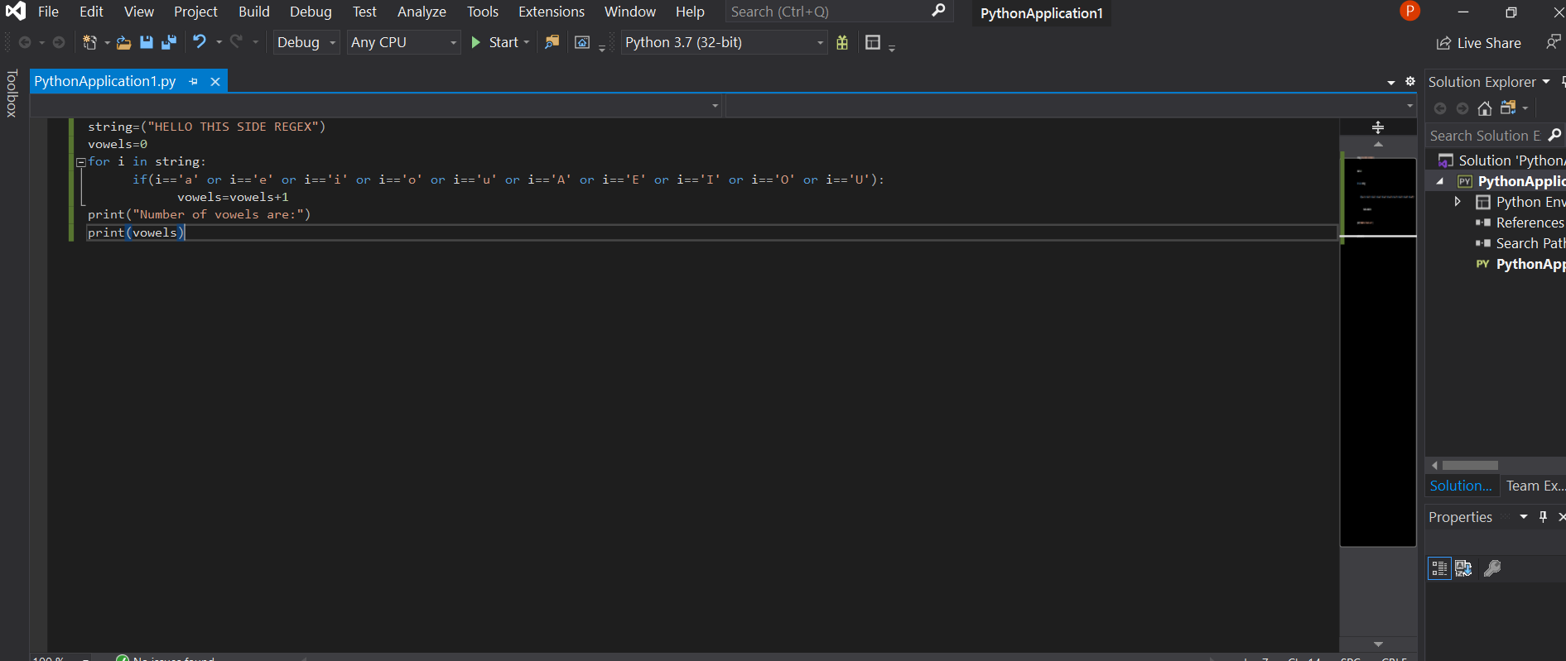

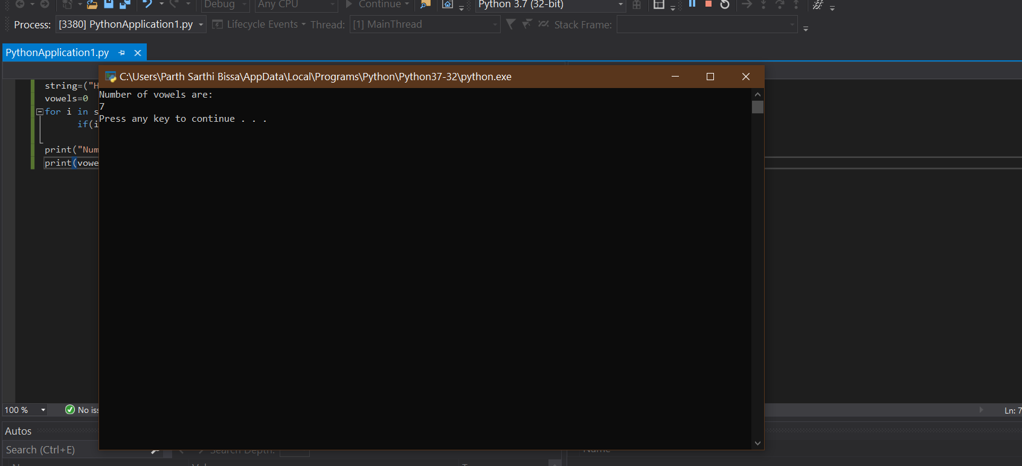

Answer 4 :

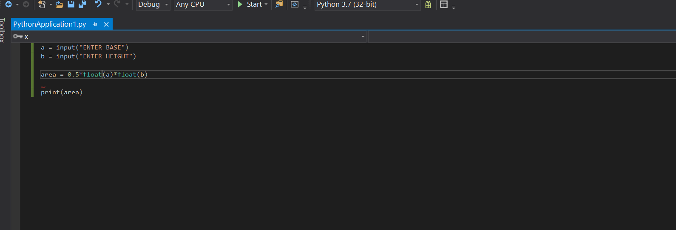

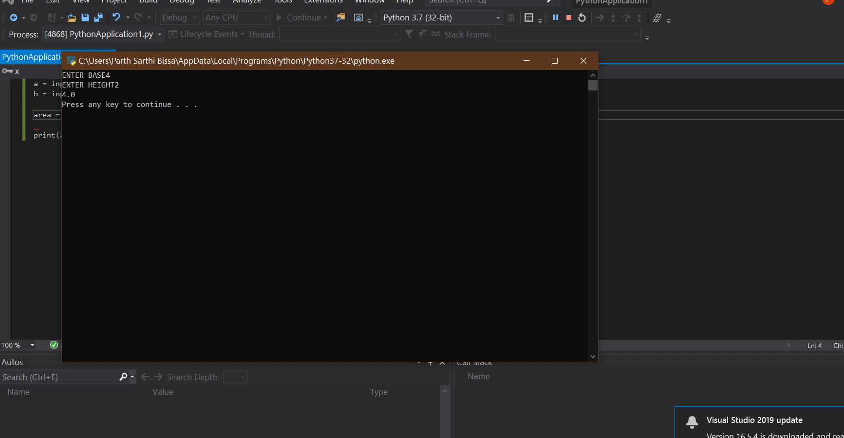

Answer 5 :

ARMSTRONG NUMBER PROGRAM

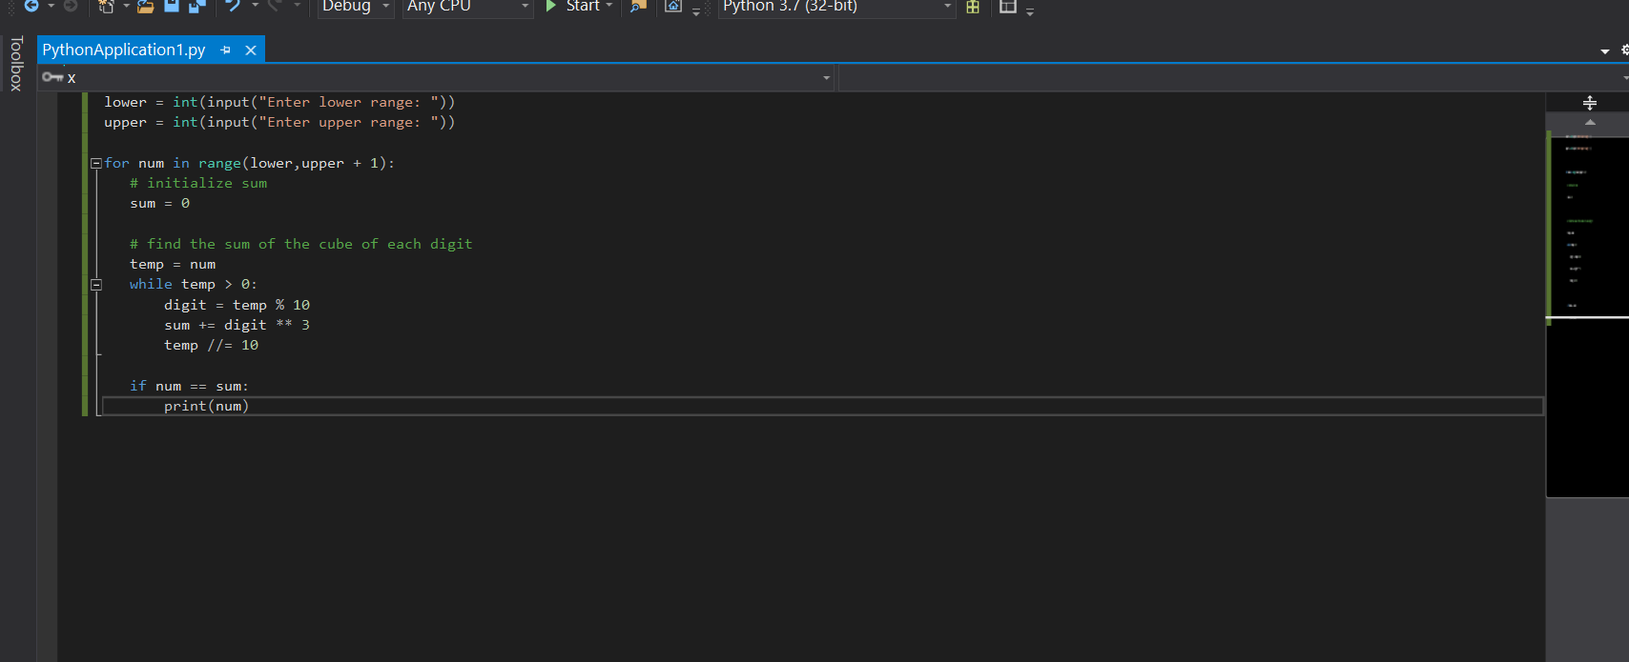

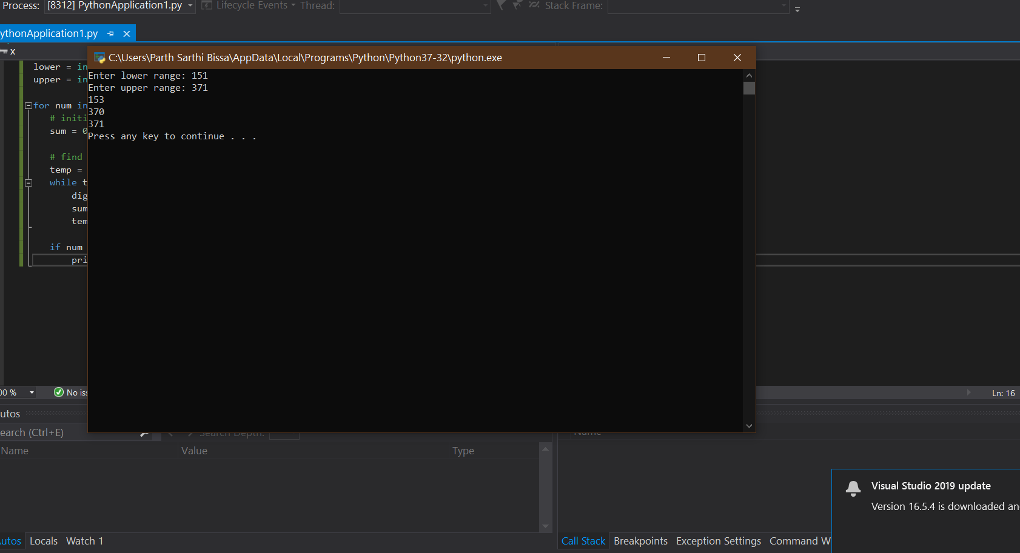

Answer 6 :

REMOVE PUNCTUATIONS FROM STRING :

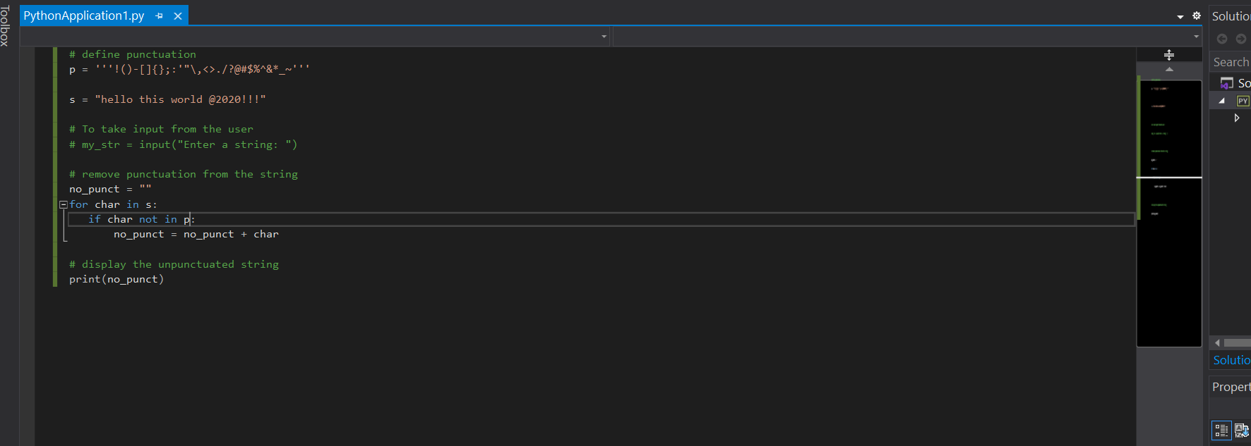

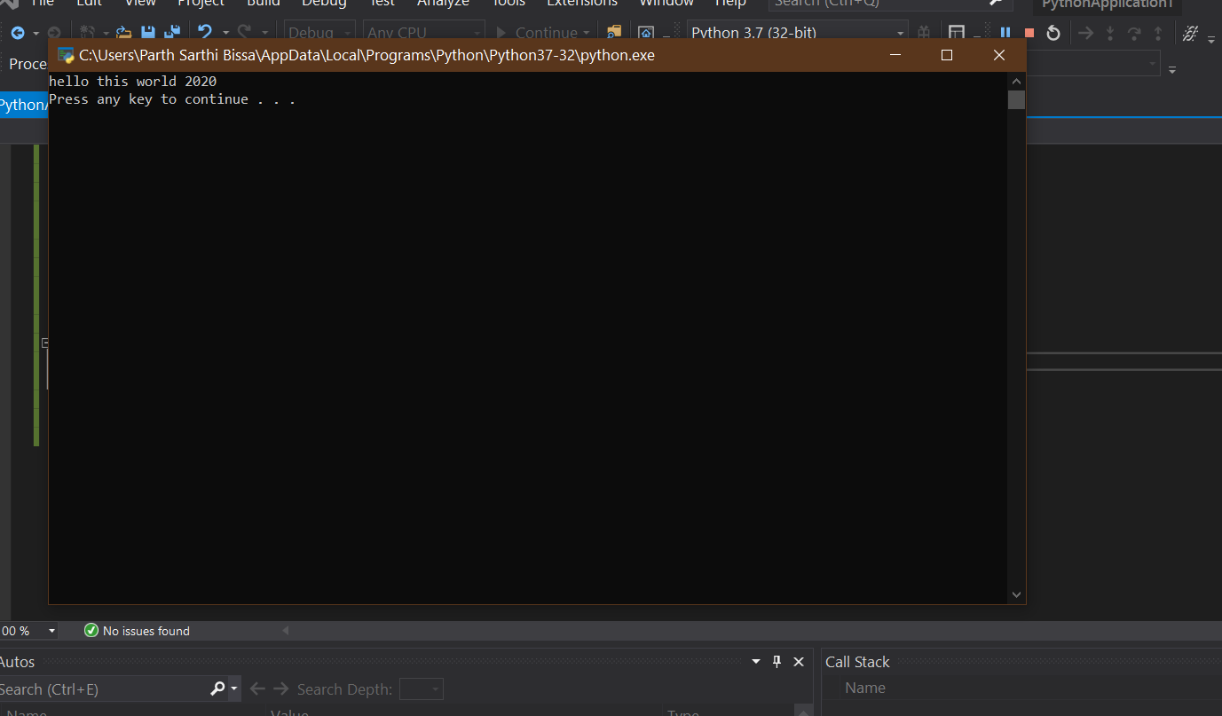

Answer 7 :

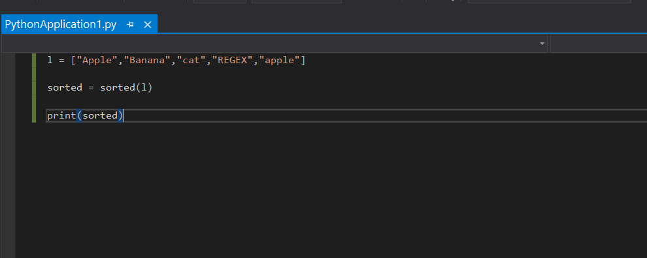

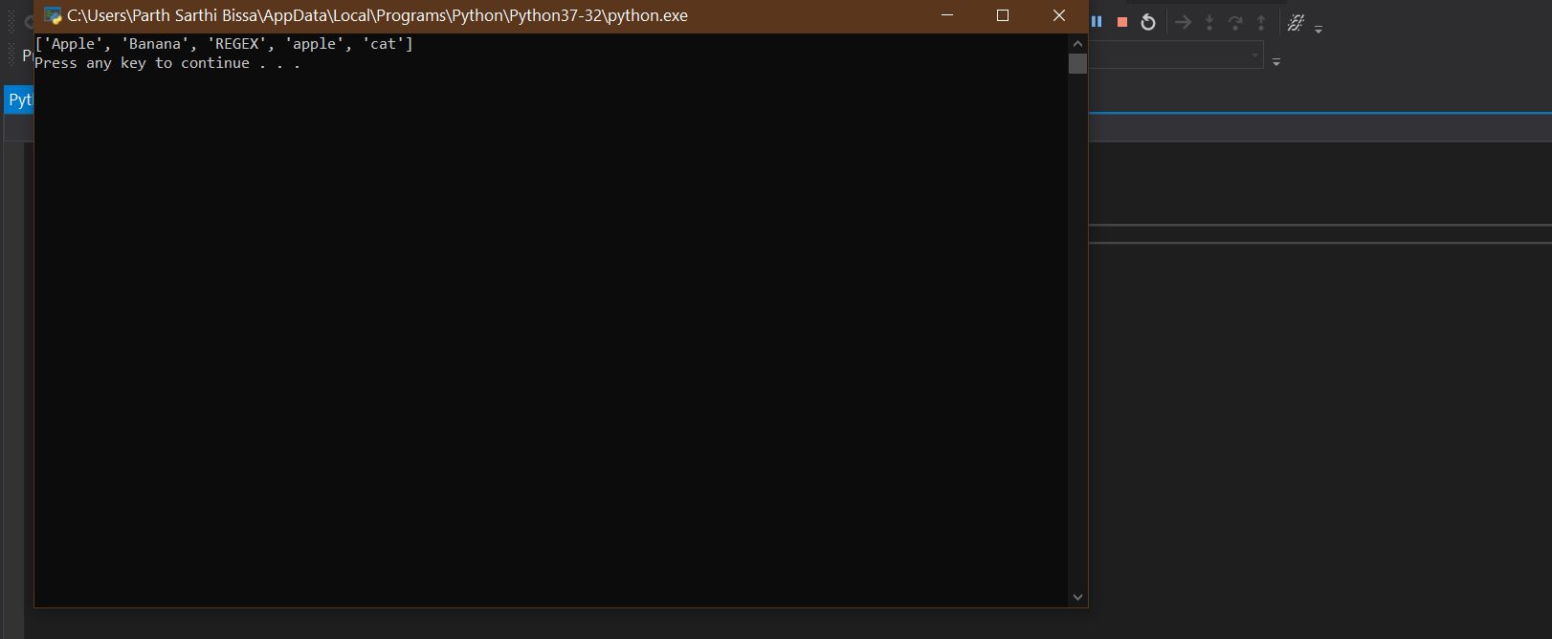

SORTING WORKS FIRSTLY ON ALL UPPERCASE STARTING ALPHABETS AND THEN ON THE LOWERCASE STARTING ALPHABETS